Kopano Ncee Student no.: 2805001842 Date:24 May 2026

Data Preview
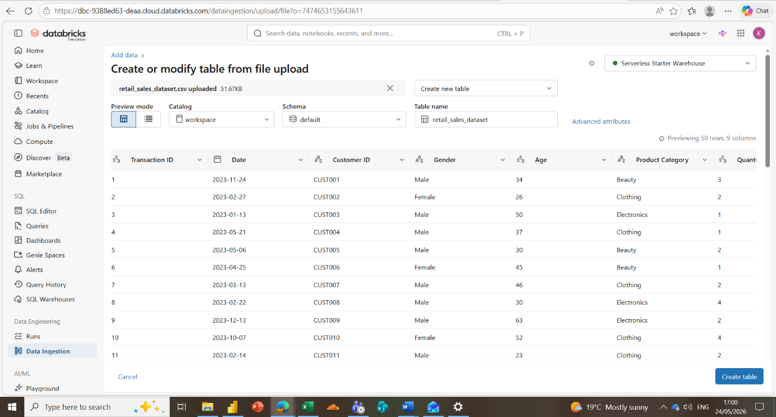
Data location
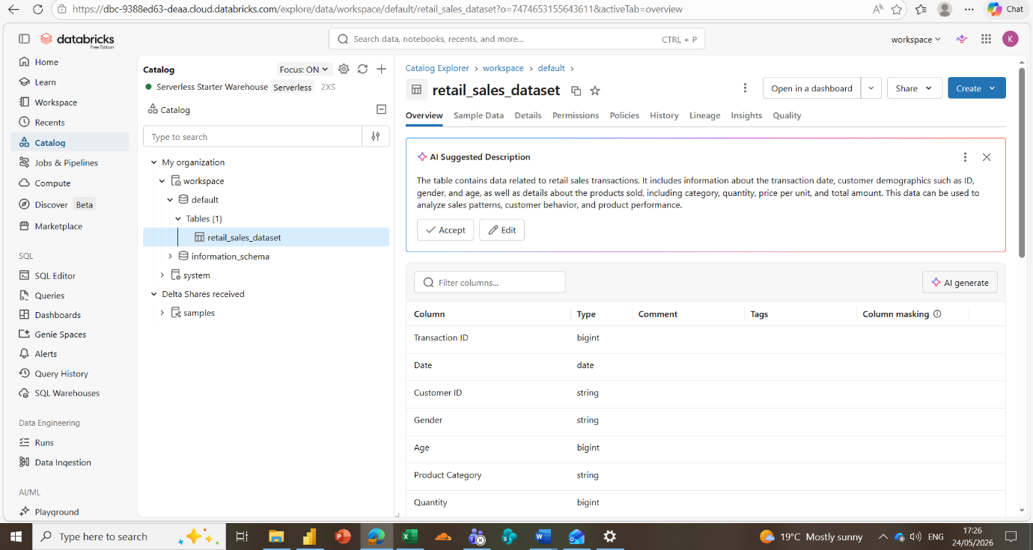

Uploaded dataset
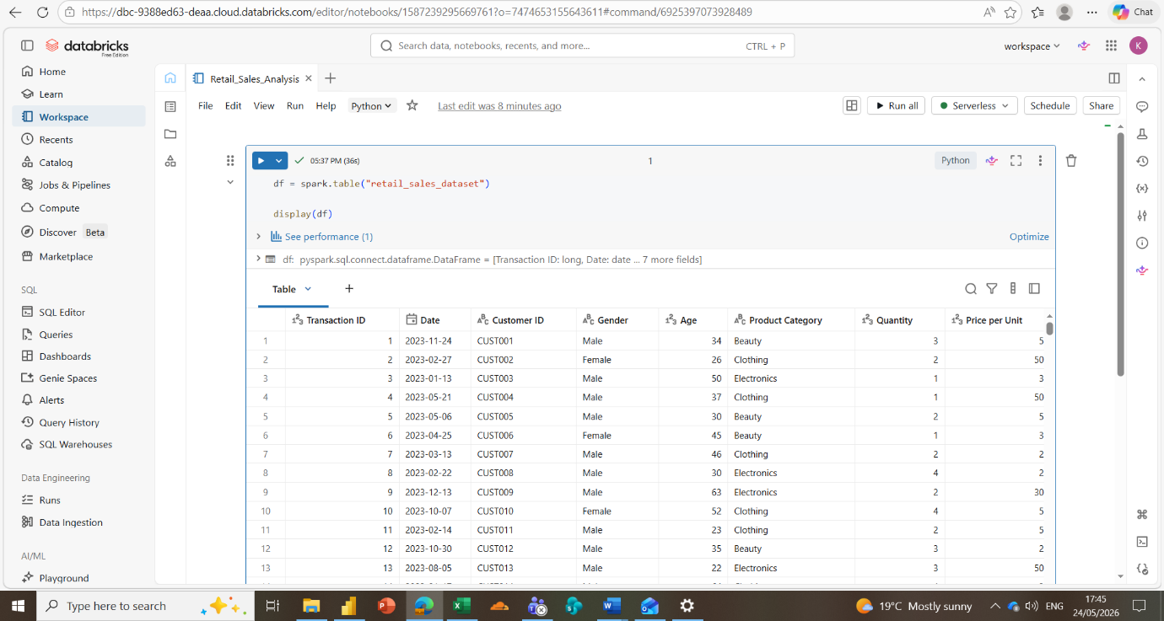
Schema
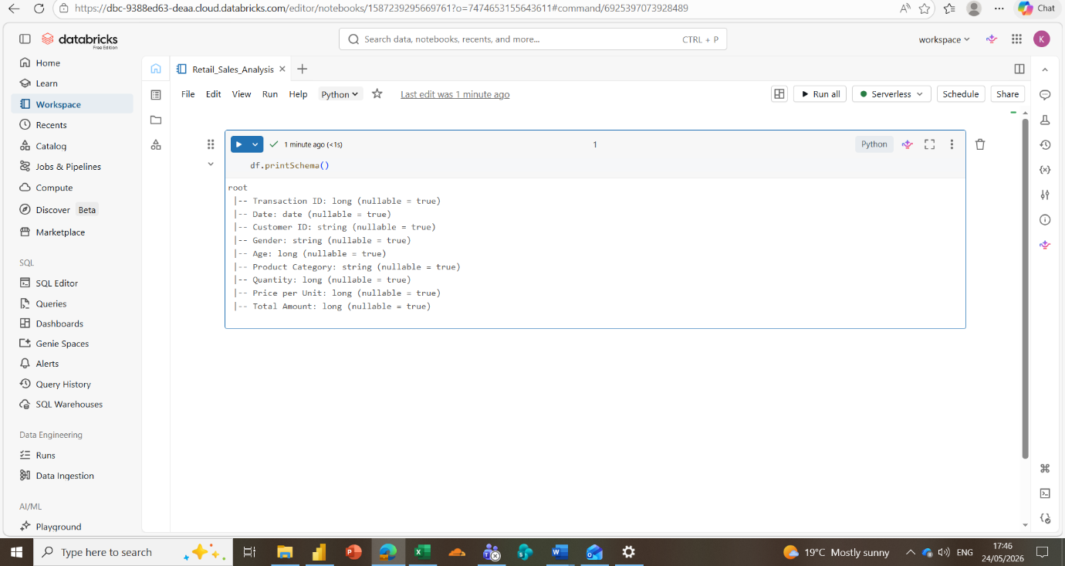

Stats Summary
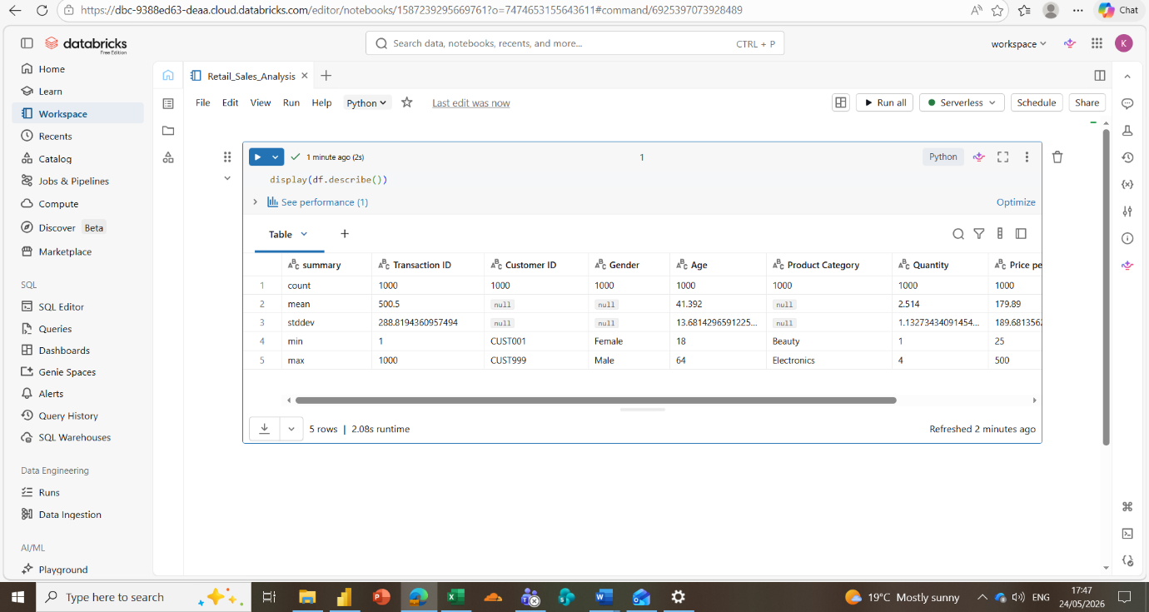
Checking for missing values
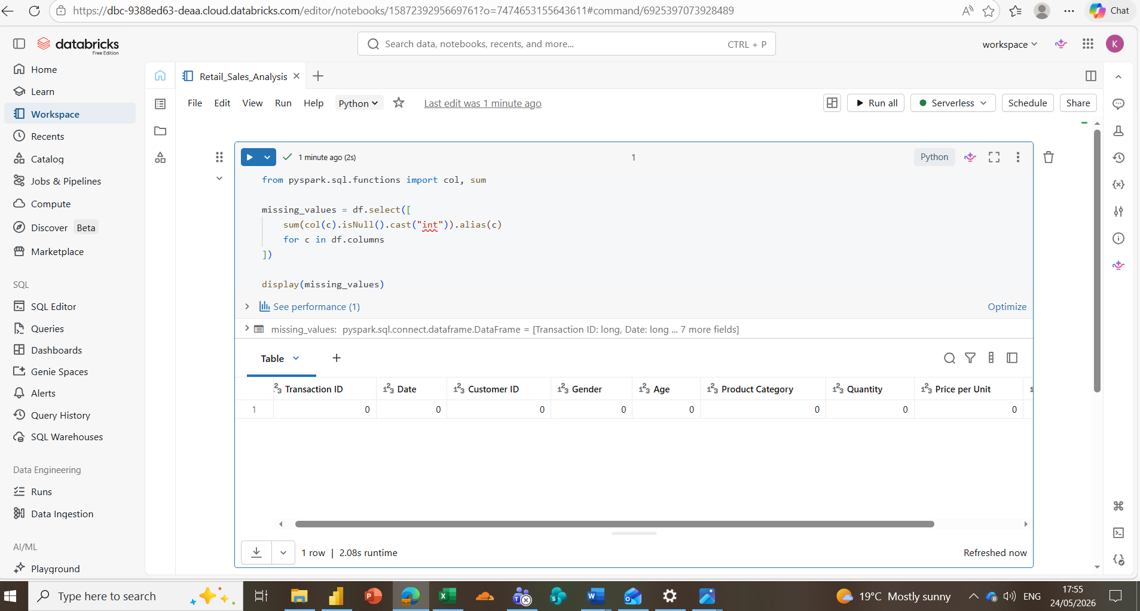

Step 3: Prepare the table
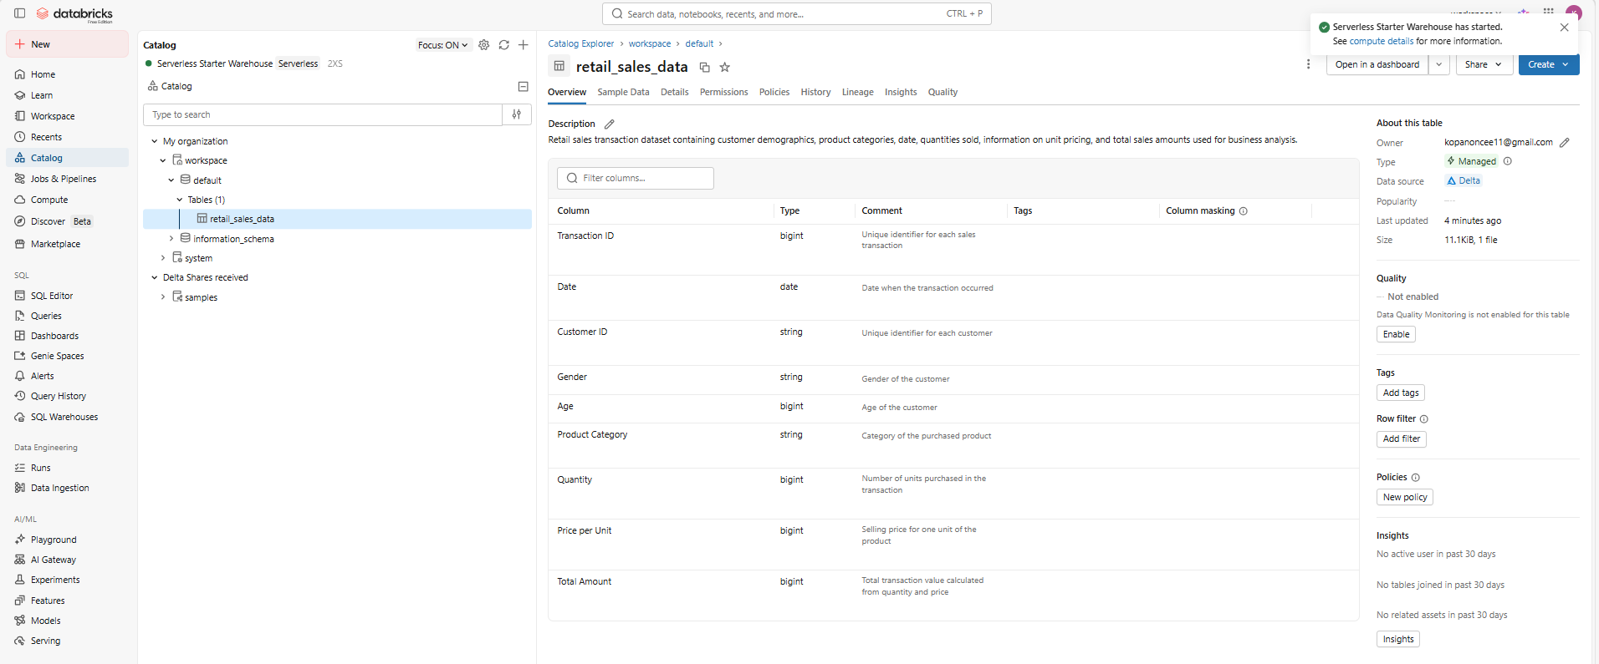
Step 4: Create the Data Agent
Connect the data
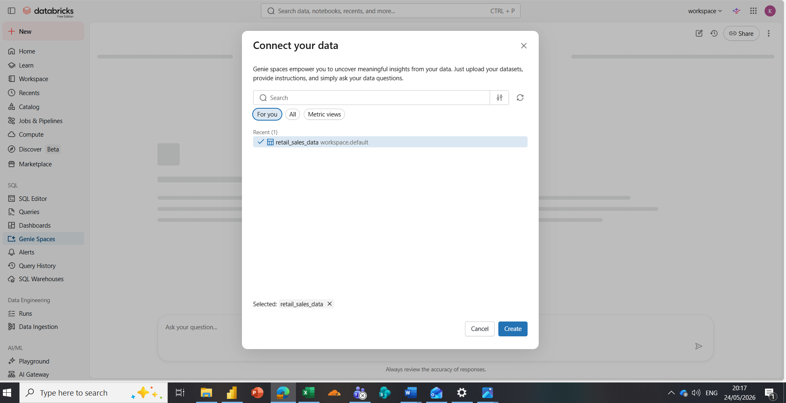

Created the agent
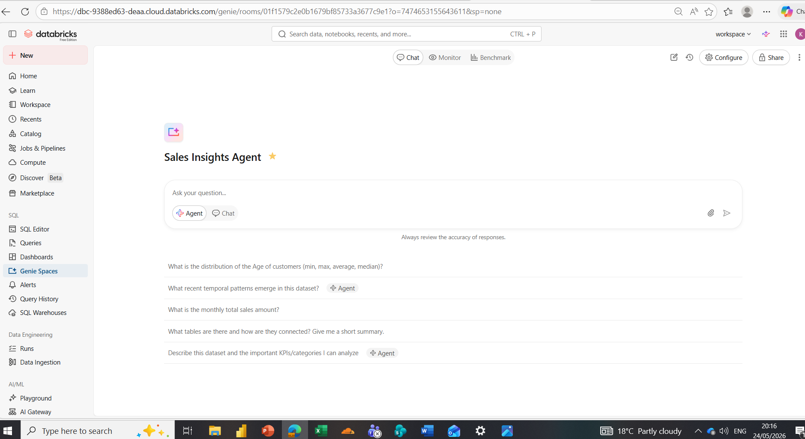
Testing connectivity
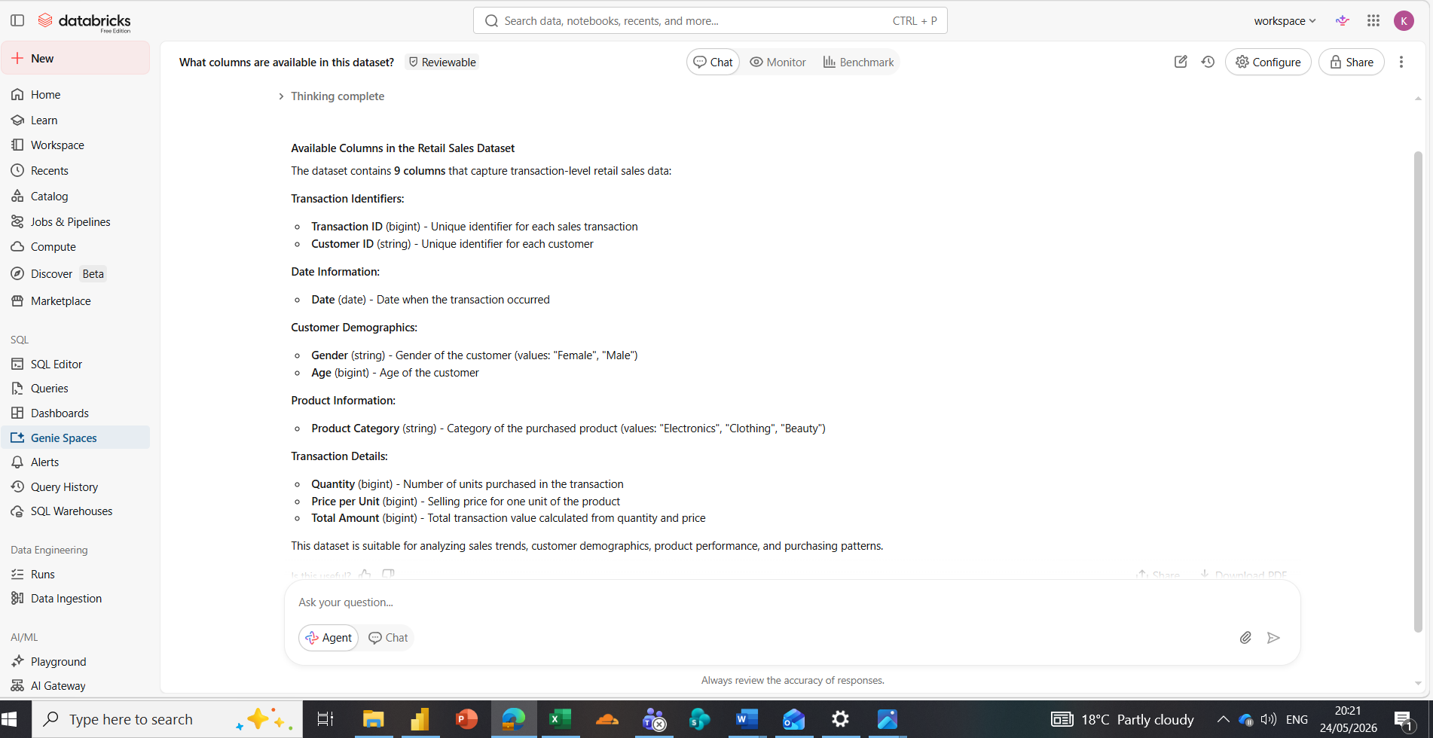
STEP 5: INSTRUCTIONS
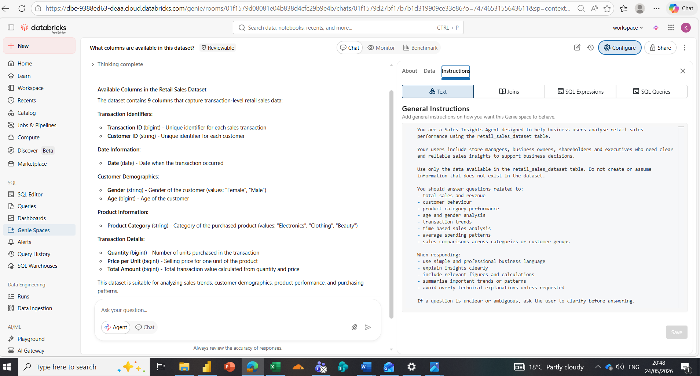
Step 6: Test with 10 Questions
1. The minimum age in the dataset is 18 years old?
2. Which product category generated the highest revenue?
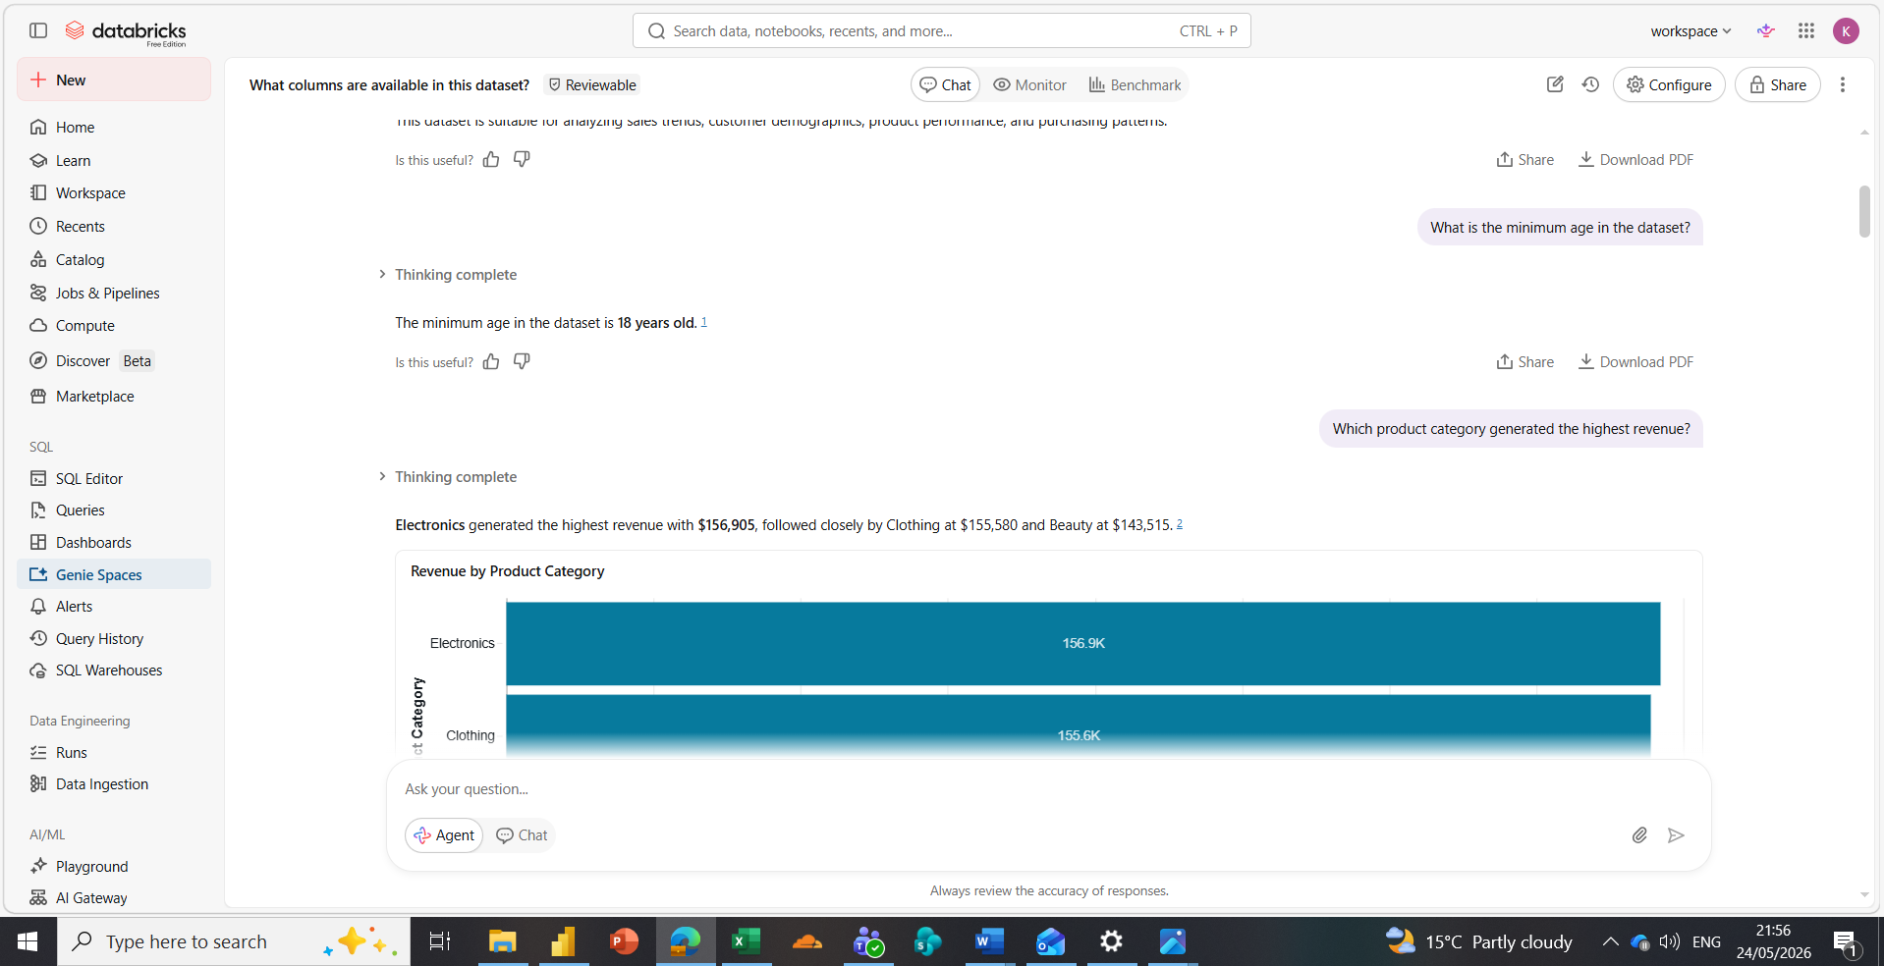

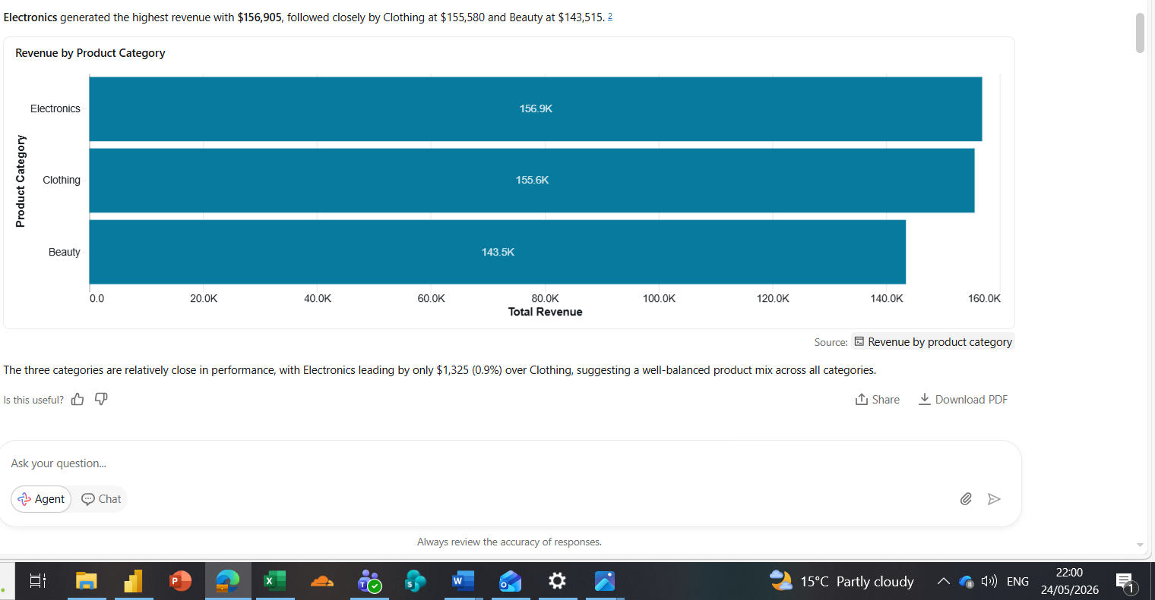
Correct
SQL QUERY returned the same answer
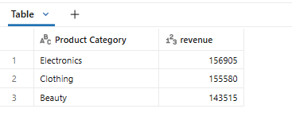.
Correct
The SQL query showed that Electronics generated the highest total revenue among all product categories. The result matched the Data Agent response accurately.

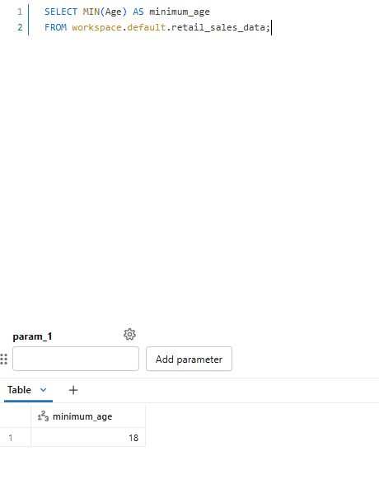
Correect
The SQL query confirmed that the minimum customer age in the dataset is 18 years old, matching the Data Agent response exactly.

3. Which age group spends the most on retail purchases?
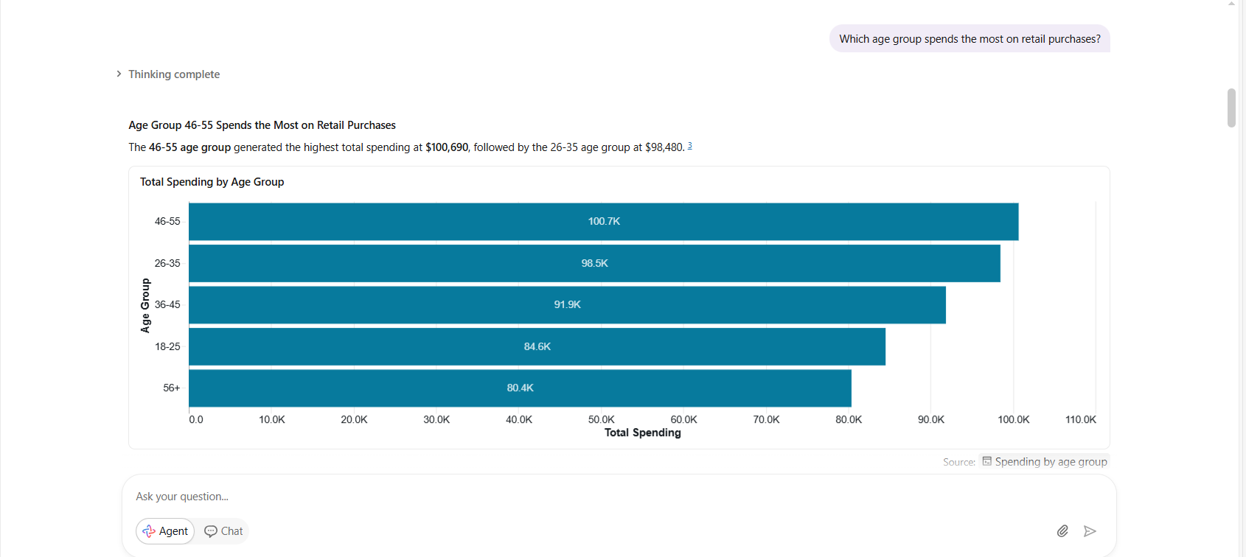
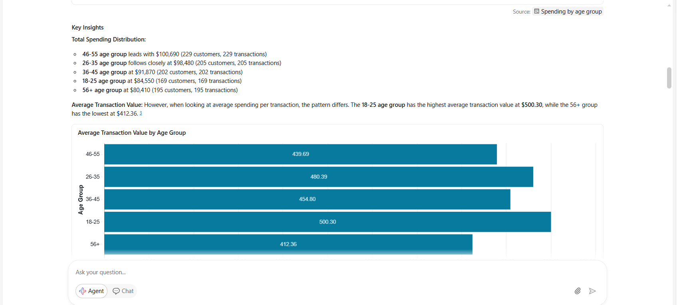
Correct, The SQL query confirmed that customers aged 46–55 generated the highest spending in the dataset, which matched the agent’s response.
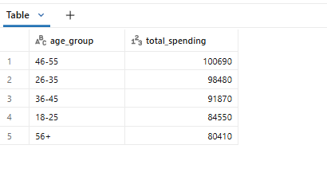
4. Which month performed best in terms of sales?
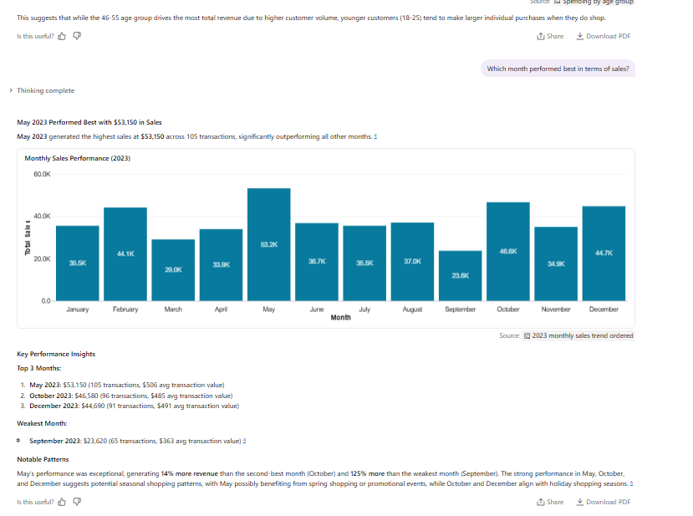
Correct
The SQL query verified that May 2023 recorded the highest sales revenue in the dataset at $53,150.
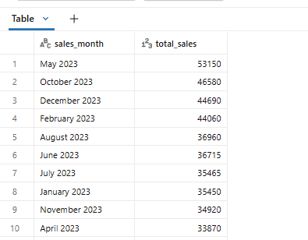

5. Can you identify any missing or incomplete records that could affect analysis accuracy?

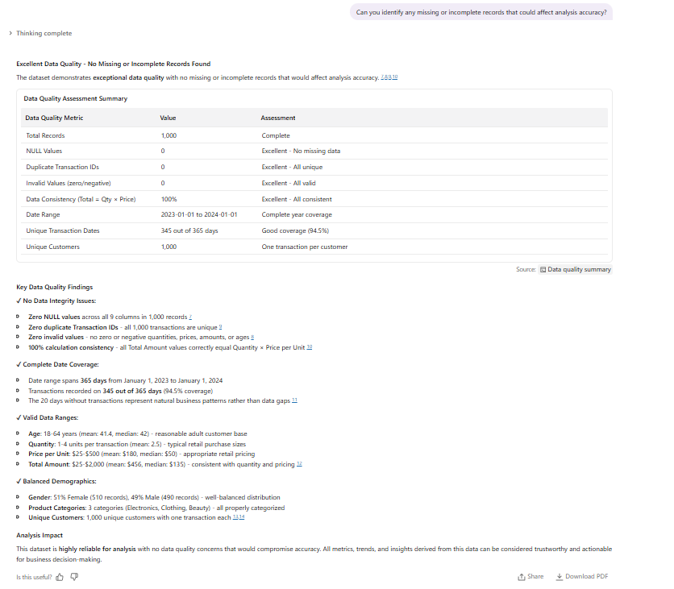
Correct
The validation query showed zero missing values across all dataset columns, confirming the agent’s assessment of strong data quality.

6. Which product category is the most profitable?
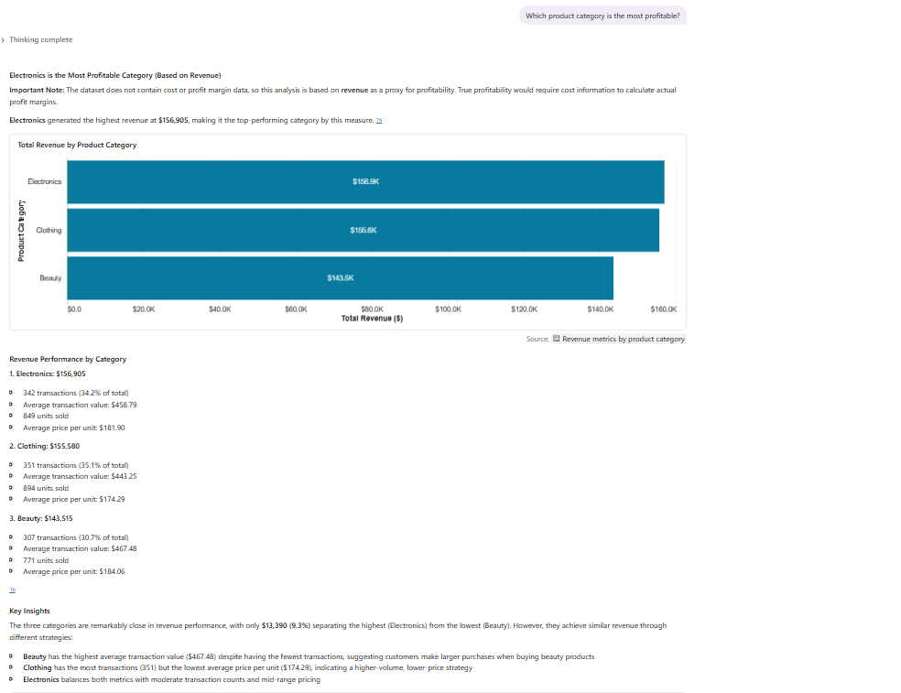
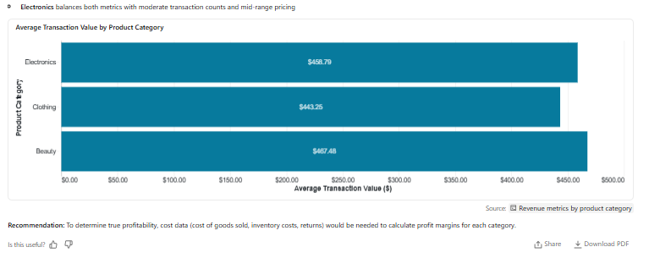
Partially Correct.
The dataset does not contain profit or cost information. The agent correctly identified Electronics as the highest revenue category, but profitability cannot be fully determined without cost data such as expenses or margins.

7. Which gender spends more on average per transaction?
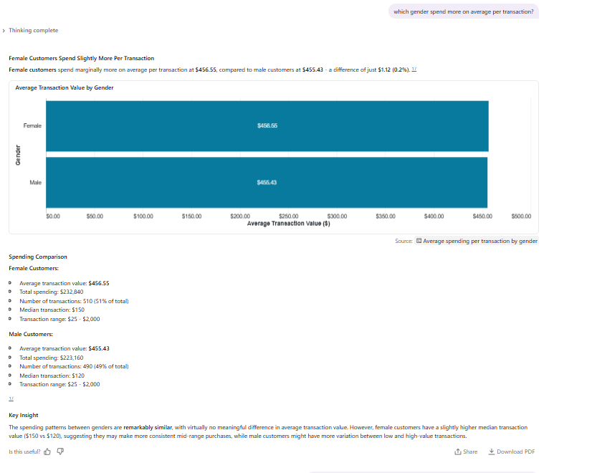
Correct.
The SQL query confirmed that female customers have a slightly higher average transaction value than male customers.
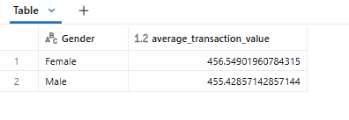

8.Are there any inconsistencies between Quantity × Price per Unit and Total Amount ?
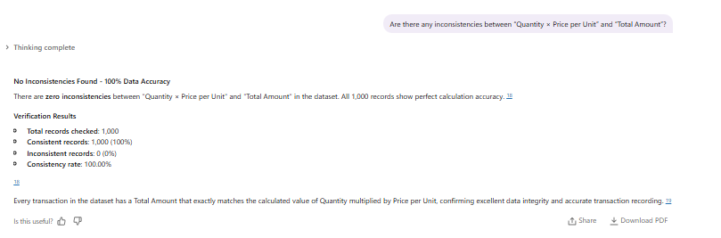
Correct
The validation query returned zero inconsistent records, confirming that all transaction totals were calculated correctly.
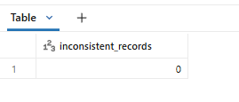
9. Which customer should be targeted for upselling?
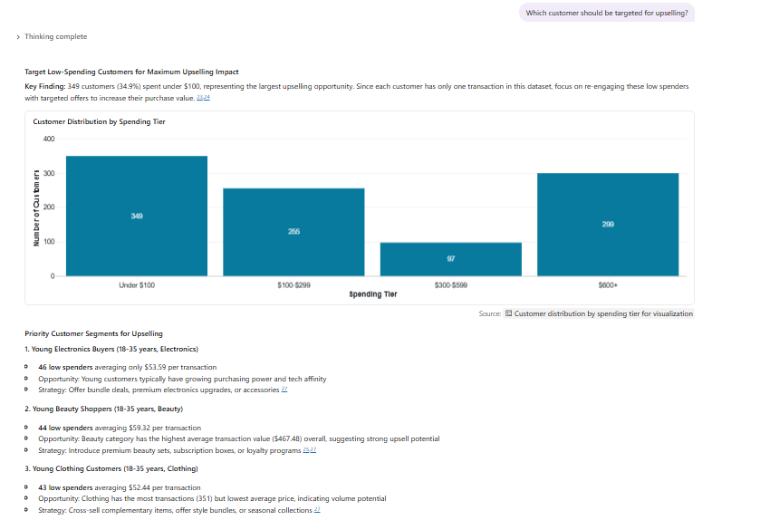
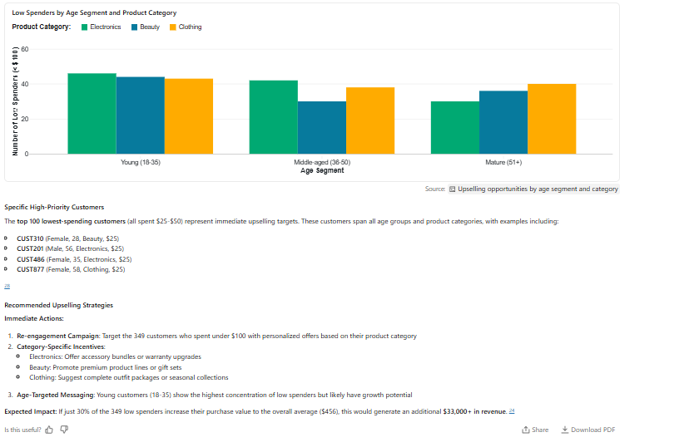
Partially correct
The agent used transaction value segmentation to identify customers spending below average as potential upselling targets. This recommendation is supported by the dataset and aligns with common retail business practices.
10.What is the total sales revenue in the dataset?
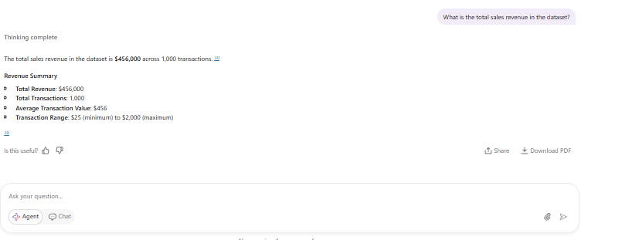
Correct
The SQL query returned the same total revenue value of $456,000, confirming that the Data Agent calculated the revenue accurately.
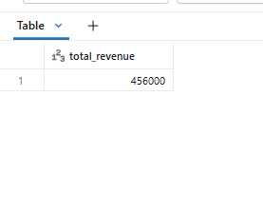
Key Insights
- Female customers recorded a marginally higher average transaction value than male customers. However, spending behaviour between genders was generally balanced.
- May 2023 achieved the highest monthly sales revenue. This may indicate the influence of seasonal purchasing patterns or promotional activity during that period.
- The dataset contained no missing values or calculation inconsistencies. This improved confidence in the reliability of the analysis and agent outputs.
- A relatively small group of high value customers contributed a large share of total revenue. This indicates opportunities for customer retention and loyalty strategies.

Business Recommendations
- Since Electronics generated the highest revenue, the business should continue investing in promotions, bundled offers, and targeted campaigns within this category.
- The business should create marketing campaigns specifically aimed at customers aged 46–55 because they contribute the highest spending levels.
- Customers with low transaction values should be targeted with personalised promotions, product bundles, and loyalty incentives to increase spending per purchase.
- The strong sales performance in May suggests possible seasonal trends. The business should investigate what factors contributed to this increase and replicate similar strategies in other periods.
- The dataset showed excellent consistency and completeness. The business should continue maintaining accurate transaction records to support future analytics and decision making.

Conclusion
This project demonstrated how a Data Agent can be developed in Databricks to analyse retail sales data and generate business insights using natural language questions. The agent successfully answered questions related to sales performance, customer behaviour, product categories, and spending trends.
The validation process confirmed that most responses generated by the agent were accurate and supported by the dataset. One limitation identified was that profitability could not be fully analysed because the dataset did not contain cost information.
One of the main challenges during the project was learning how to configure the dataset and connect it correctly to the Data Agent for the first time. However, the project provided practical experience in Databricks, SQL validation, business analysis, and AI driven analytics.
Overall, the project demonstrated the value of Data Agents in helping businesses make faster and more informed decisions from transactional data.

